Test Case: tc002_SPX_Dev5_Crear_Requisicion_Spot_Tipo_Cobro_Project
Step 1 - Enter username and password and click to button Enter: Credentials Entered
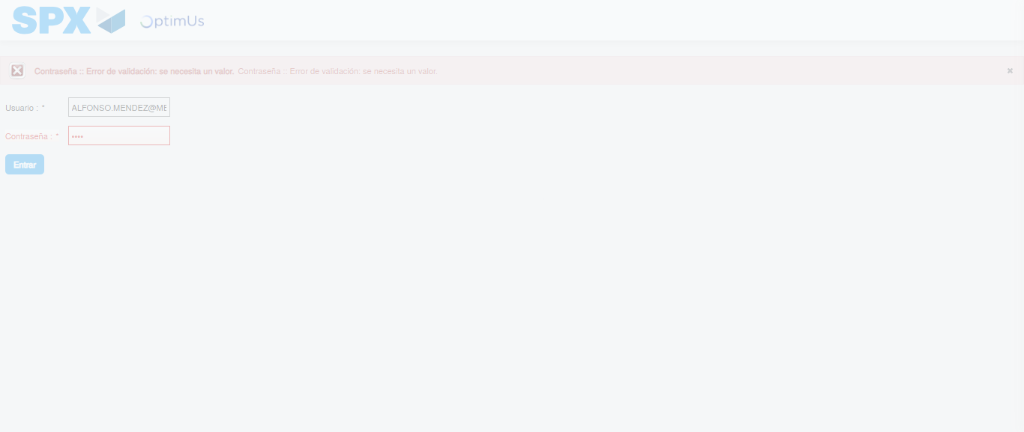Image file-name: QC_Testing-tc002_SPX_Dev5_Crear_Requisicion_Spot_Tipo_Cobro_Project-1783361504041

Step 2 - Select to UEN and Access to Spot Buy Requisitions : UEN Correctly selected and Correct access
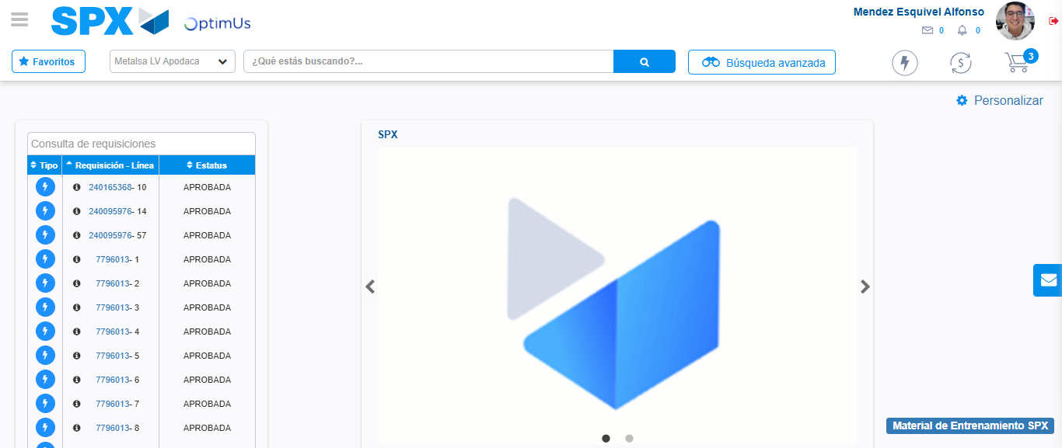Image file-name: QC_Testing-tc002_SPX_Dev5_Crear_Requisicion_Spot_Tipo_Cobro_Project-1783361529413

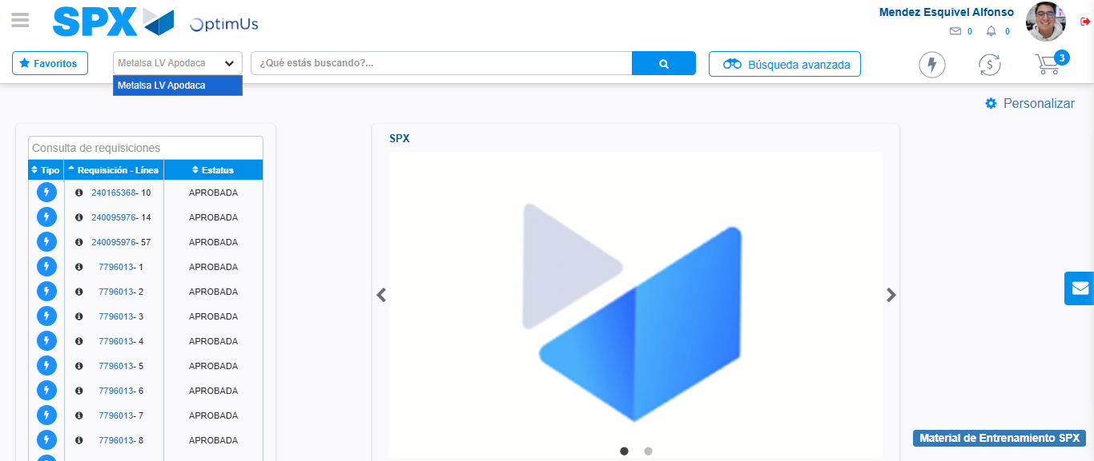Image file-name: QC_Testing-tc002_SPX_Dev5_Crear_Requisicion_Spot_Tipo_Cobro_Project-1783361532009

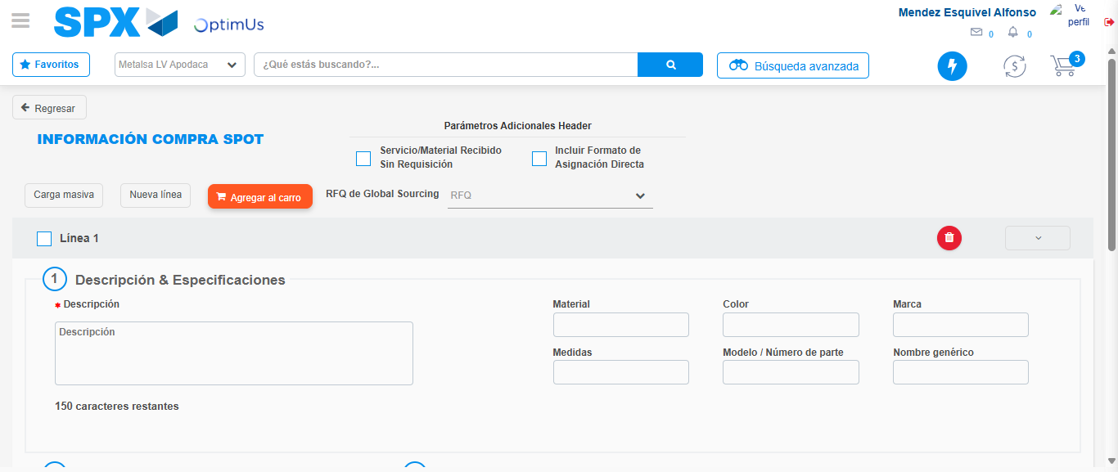Image file-name: QC_Testing-tc002_SPX_Dev5_Crear_Requisicion_Spot_Tipo_Cobro_Project-1783361551660

Step 3 - Data Capture Spot Buy Requisition: Data captured correctly
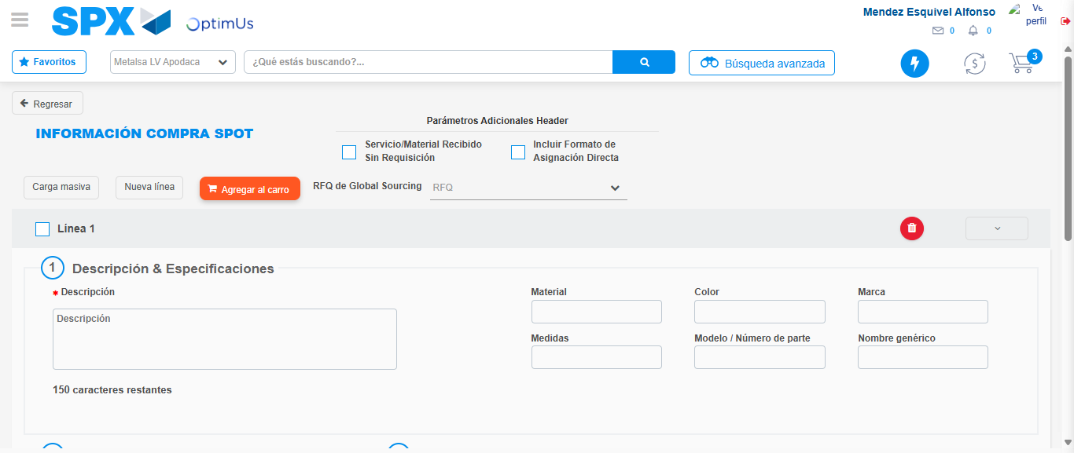Image file-name: QC_Testing-tc002_SPX_Dev5_Crear_Requisicion_Spot_Tipo_Cobro_Project-1783361551975

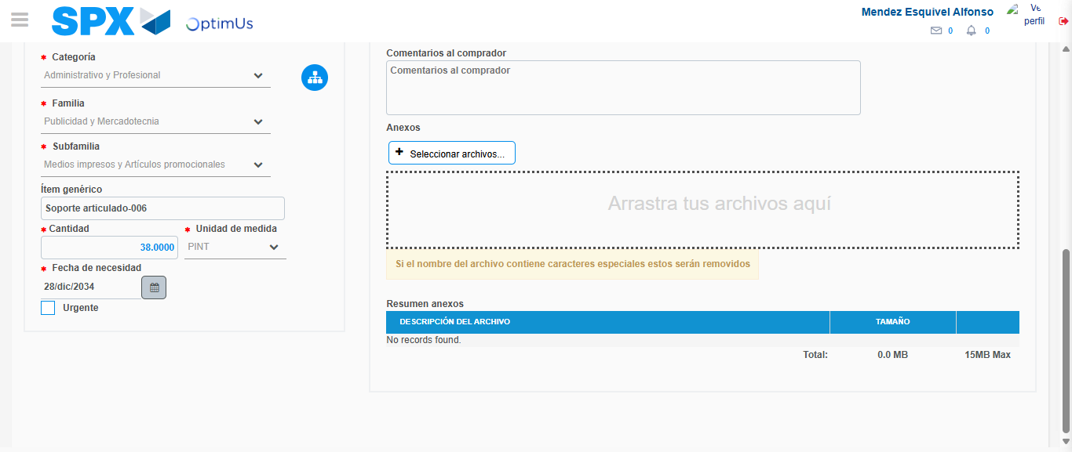Image file-name: QC_Testing-tc002_SPX_Dev5_Crear_Requisicion_Spot_Tipo_Cobro_Project-1783361564395

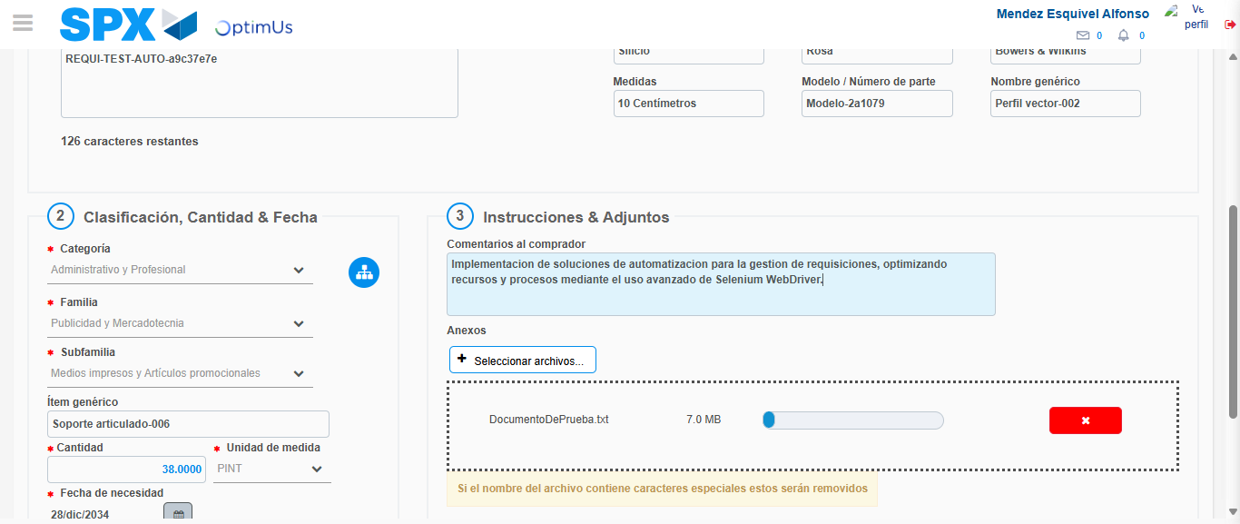Image file-name: QC_Testing-tc002_SPX_Dev5_Crear_Requisicion_Spot_Tipo_Cobro_Project-1783361565331

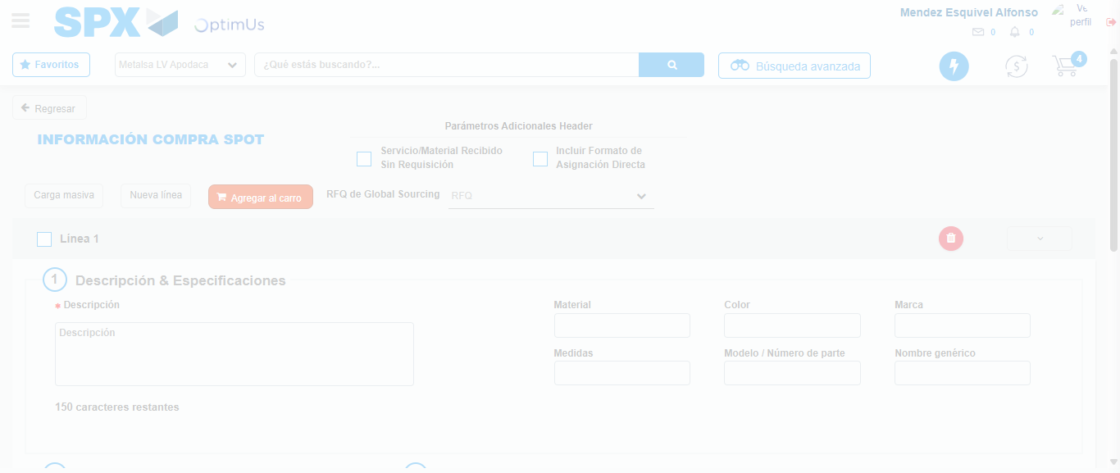Image file-name: QC_Testing-tc002_SPX_Dev5_Crear_Requisicion_Spot_Tipo_Cobro_Project-1783361571607

Step 7 - Return to Main Page SPX : Return to Main Page SPX
Image file-name: QC_Testing-tc002_SPX_Dev5_Crear_Requisicion_Spot_Tipo_Cobro_Project-1783361529413

Image file-name: QC_Testing-tc002_SPX_Dev5_Crear_Requisicion_Spot_Tipo_Cobro_Project-1783361532009

Image file-name: QC_Testing-tc002_SPX_Dev5_Crear_Requisicion_Spot_Tipo_Cobro_Project-1783361551660

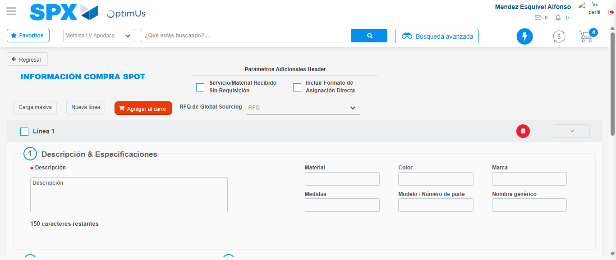Image file-name: QC_Testing-tc002_SPX_Dev5_Crear_Requisicion_Spot_Tipo_Cobro_Project-1783361573972

Image file-name: QC_Testing-tc002_SPX_Dev5_Crear_Requisicion_Spot_Tipo_Cobro_Project-1783361574213

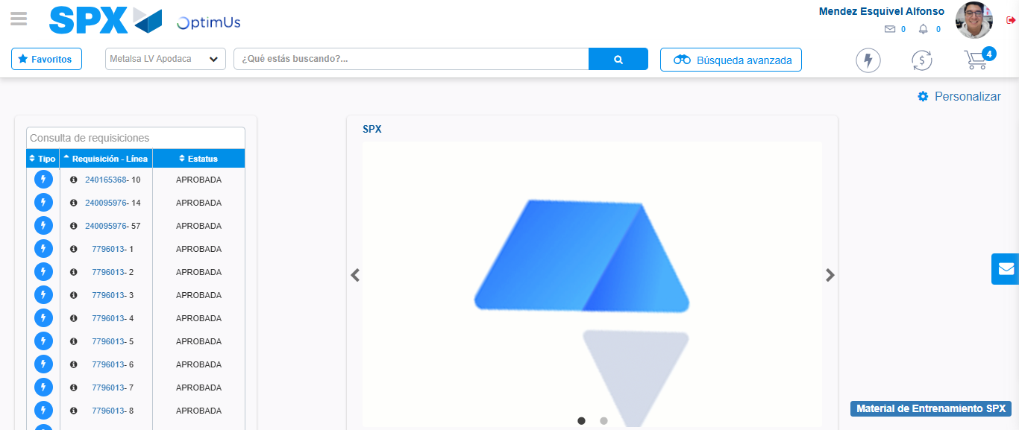Image file-name: QC_Testing-tc002_SPX_Dev5_Crear_Requisicion_Spot_Tipo_Cobro_Project-1783361595685

Step 8 - Log Out : Log Out SPX
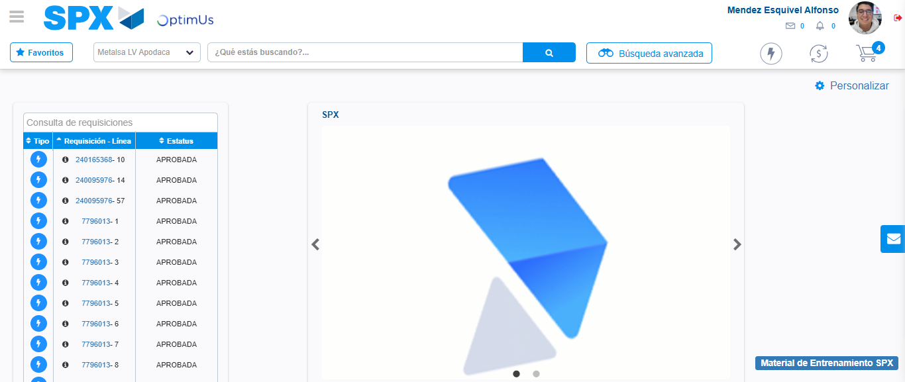Image file-name: QC_Testing-tc002_SPX_Dev5_Crear_Requisicion_Spot_Tipo_Cobro_Project-1783361595958

